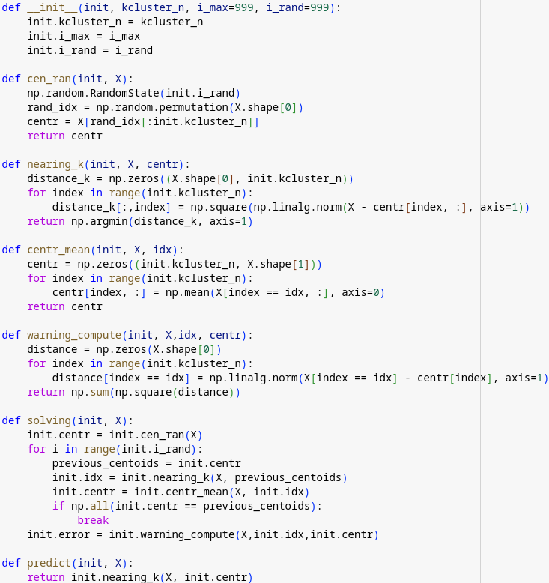

This class, Kmeans, implements the K-means clustering algorithm, which is a method used for partitioning n observations into k clusters in which each observation belongs to the cluster with the nearest mean. Here's a breakdown of what each method in the class does:
- __init__(self, kcluster_n, i_max=999, i_rand=999): The initializer method for the Kmeans class. It sets up the initial configuration for a K-means clustering instance, including the number of clusters kcluster_n, the maximum number of iterations i_max, and a random seed i_rand for reproducibility.
- cen_ran(self, X): This method initializes the centroids randomly. It uses the random state set by i_rand to shuffle the indices of the dataset X and selects the first kcluster_n instances as the initial centroids.
- nearing_k(self, X, centr): For each point in the dataset X, this method calculates the distance to all centroids and assigns the point to the closest centroid. It returns an array where each element is the index of the nearest centroid for the corresponding point in X.
- centr_mean(self, X, idx): This method recalculates the centroids as the mean of the points assigned to each centroid. It takes the dataset X and the index array idx which indicates the closest centroid for each point in X. The new centroids are calculated and returned.
- warning_compute(self, X, idx, centr): This method computes the total within-cluster sum of squares, which serves as a measure of the compactness of the clusters. It calculates the squared distance from each point to its assigned centroid and sums these distances.
- solving(self, X): This is the main method that iteratively performs the clustering process. It starts by initializing the centroids using cen_ran. Then, for a maximum of i_rand iterations, it assigns points to the nearest centroid, recalculates centroids, and checks for convergence (if the centroids do not change). The total within-cluster sum of squares is calculated at the end and stored in error.
- predict(self, X): After the model has been trained using solving, this method can be used to predict the closest centroid for each point in a new dataset X. It returns the indices of the nearest centroid for each point.
Note: There seems to be a minor inconsistency in the usage of variable names (init should conventionally be self in the context of class methods in Python). Additionally, there's a potential mistake in the solving method loop condition, where it iterates i_rand times instead of i_max times, which could be a typo since i_max is meant to limit the number of iterations during the solving process.

